**SAP TOT**

Jan,02,2025

**Day one (01-01-2025)**

**Company Code =========?**

**GL steps**

Chart of Account selected

GL-Code

Creating New GL

**Change GL**

**Post on GL**

**Upload General Journal Entry**

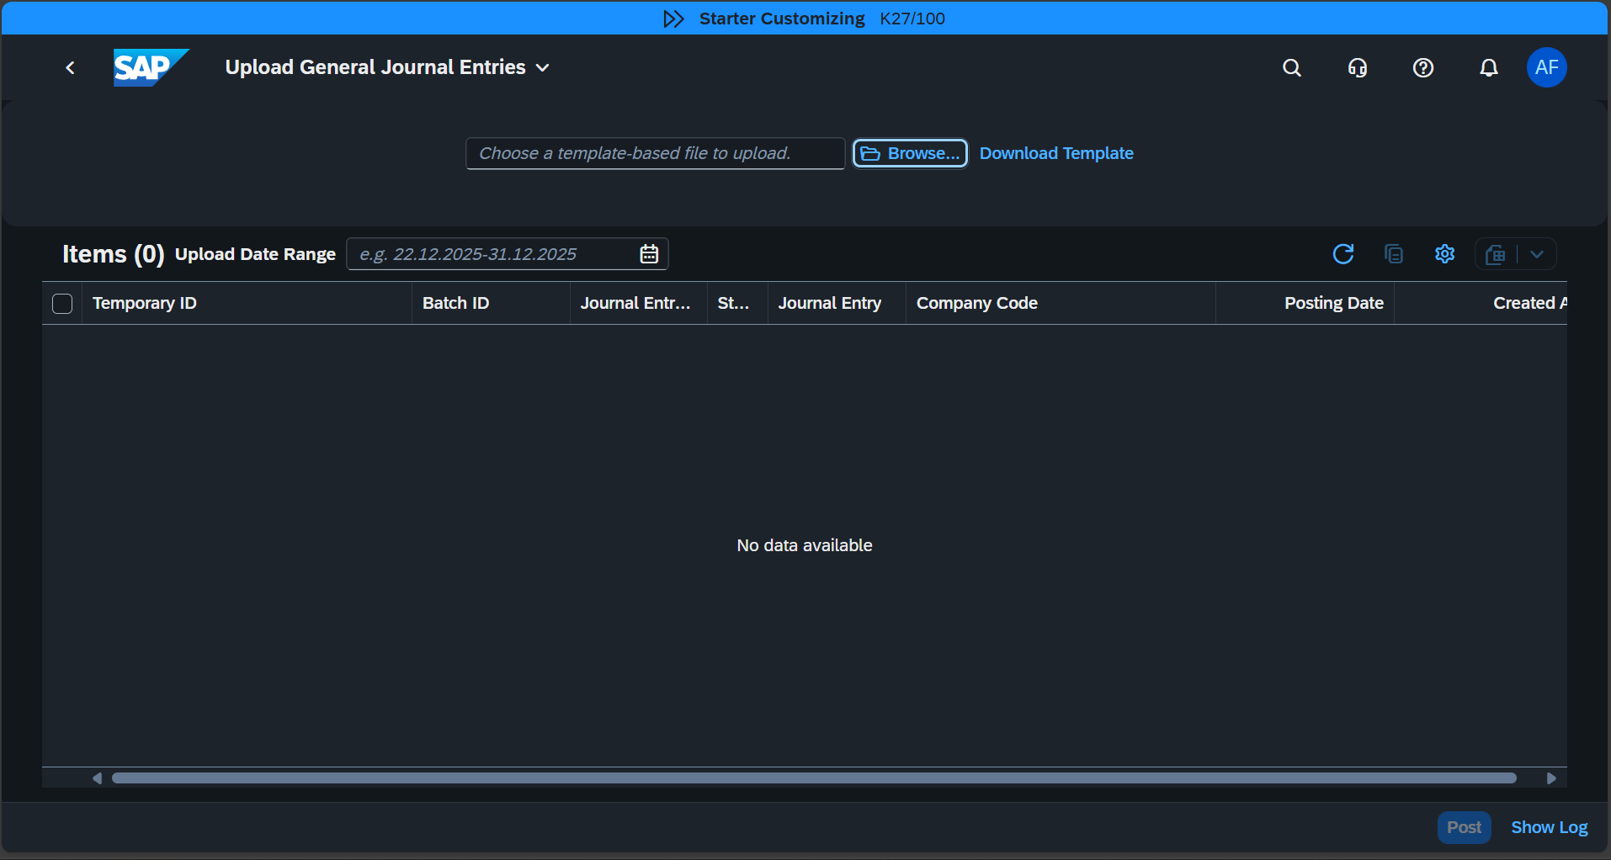

Download the template from The Journal Entry

Search: **Post on general journal:**

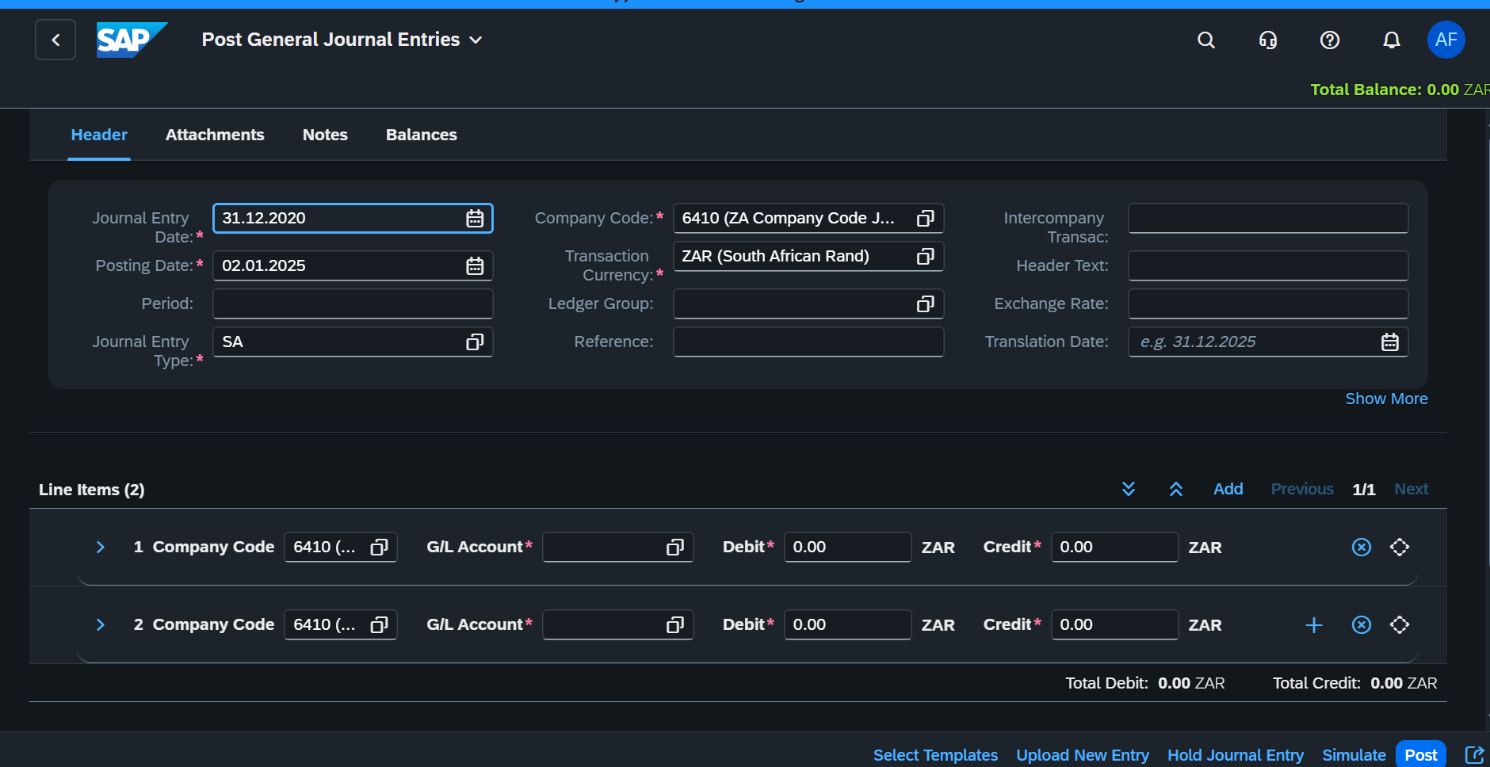

Material Management (MM)

Creating Material:

Change Material:

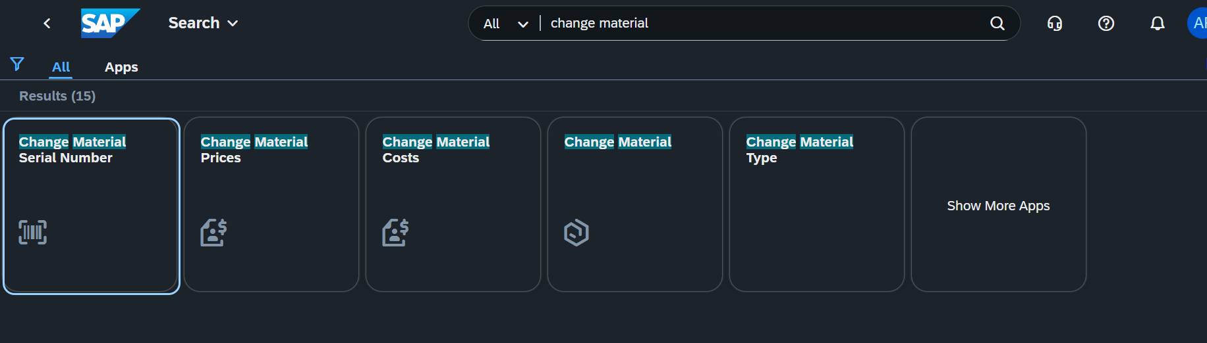

Day 02-----------1/3/2025

Display GL Account Balance

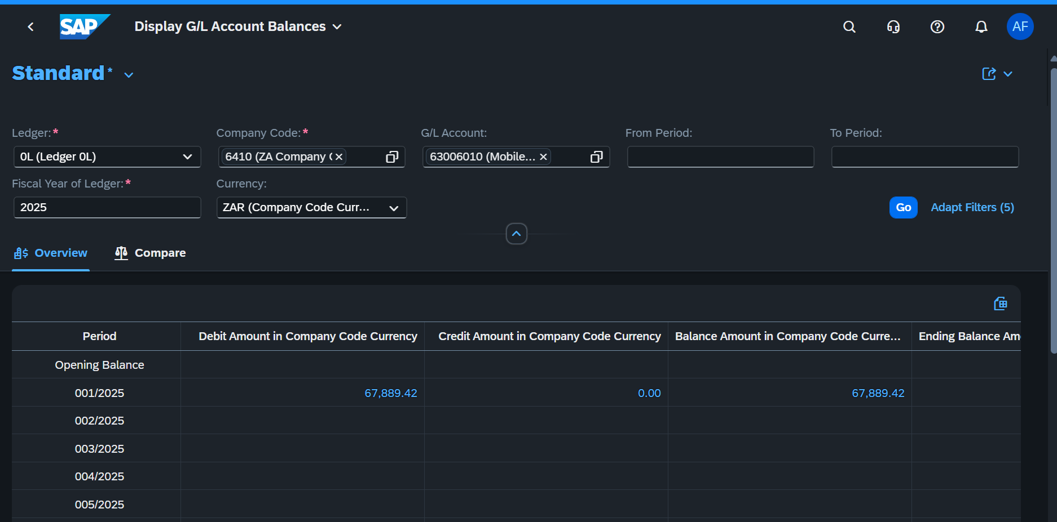

We need to Specify the fiscal year and also, we can export to spread sheet

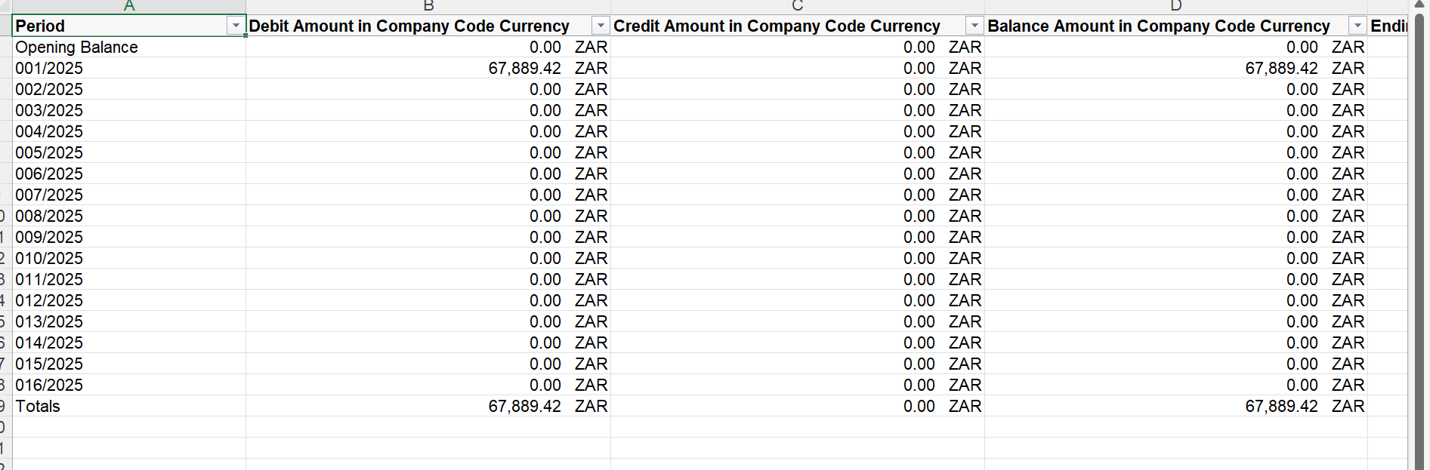

Its also possible to filter based on different criterial by Adapting filters

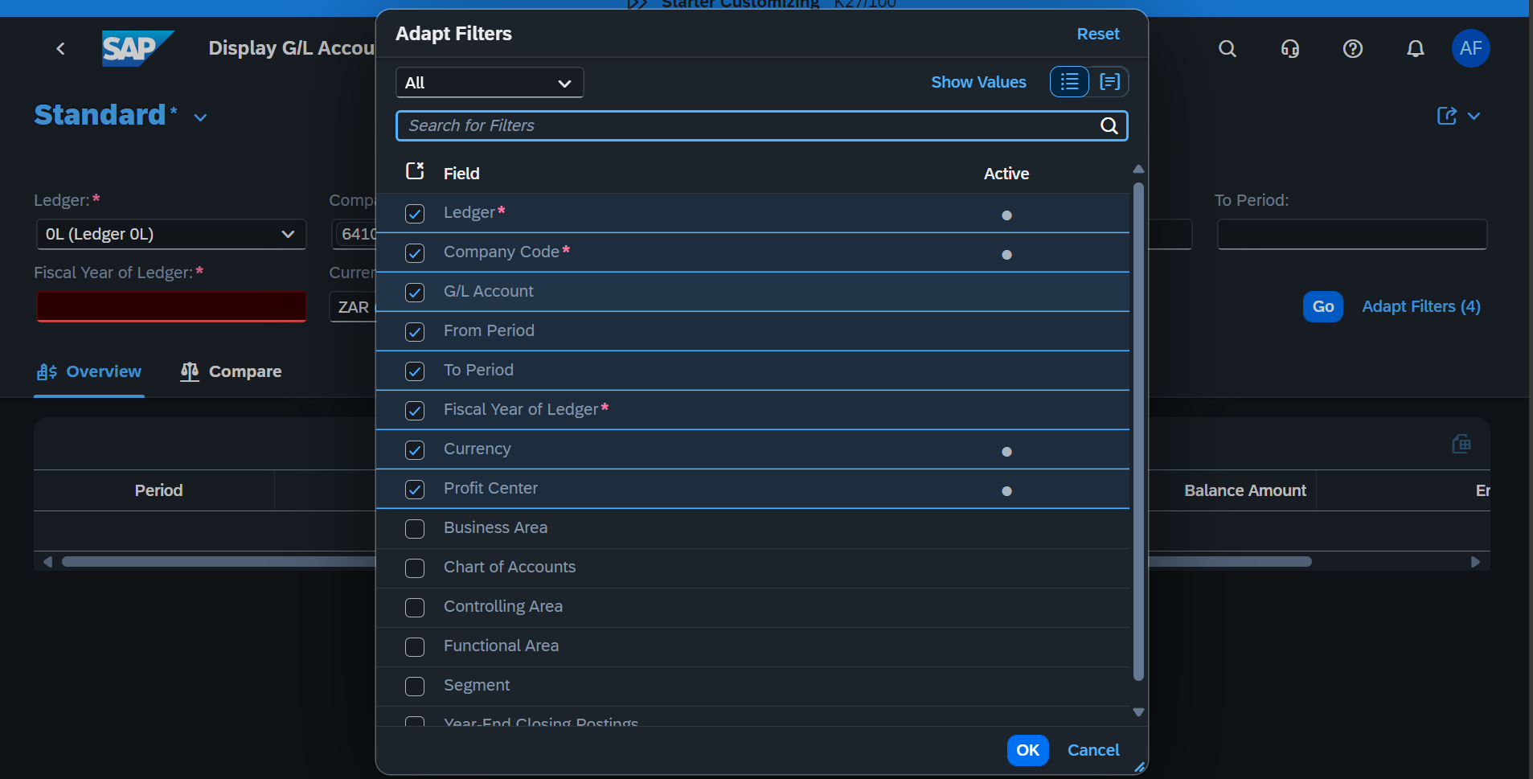

**Audit Journal**

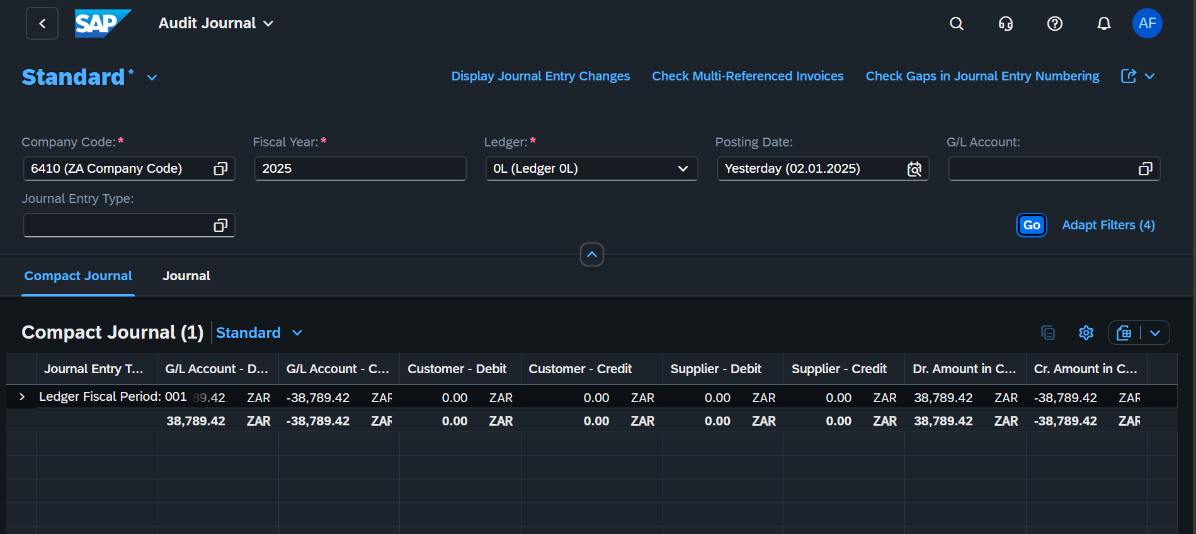

**Its also possible to reverse journal entries**

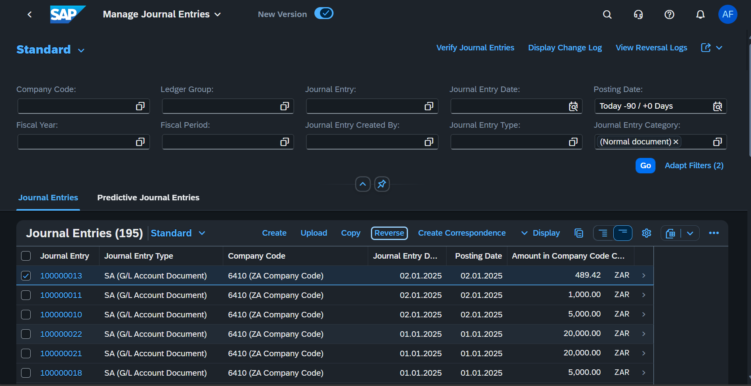

**Journal Entry Analyzer**

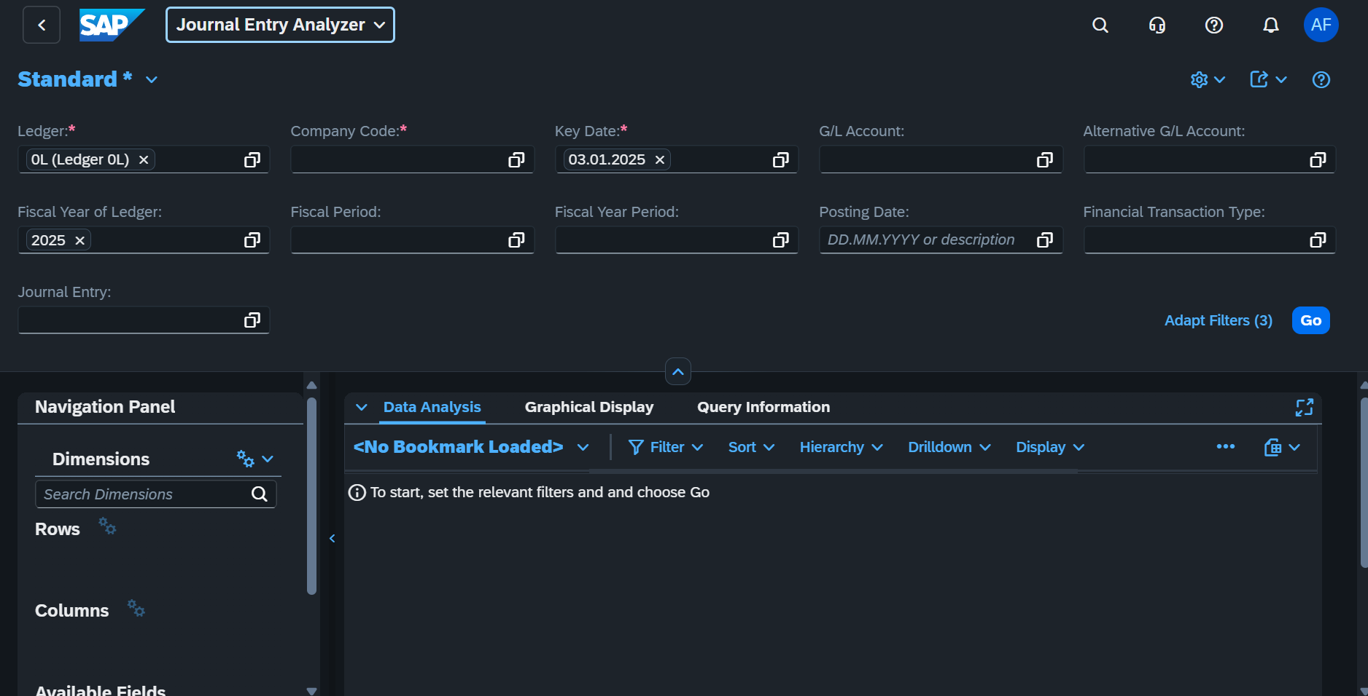

**Deduct from Bank Account**

**Currency Exchange**

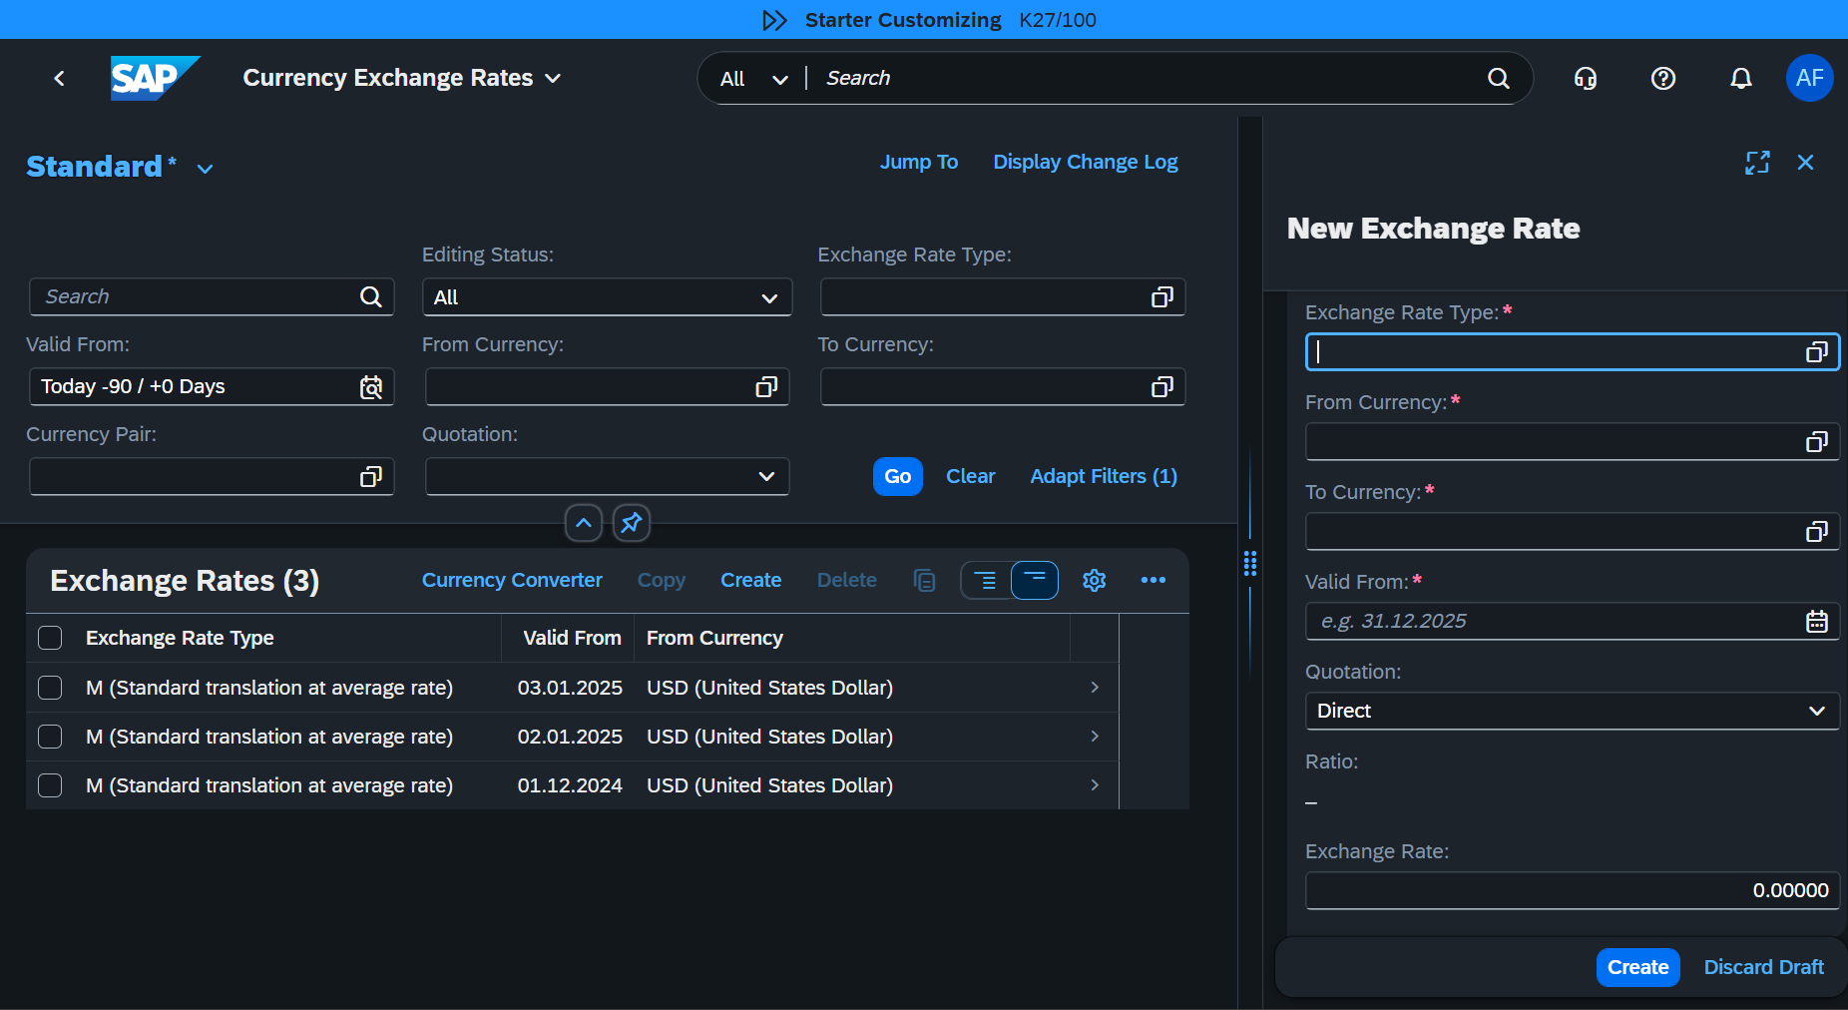

**Afternoon MM**

Create an organization

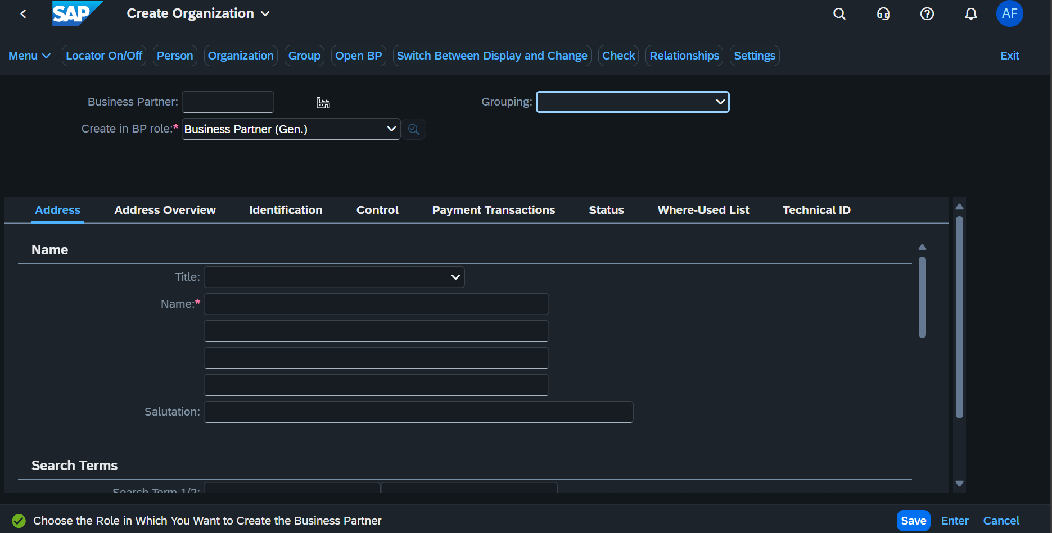

Create Purchase Request

**Account Receivable**

Manage Customer Master Data

* Display Customer List

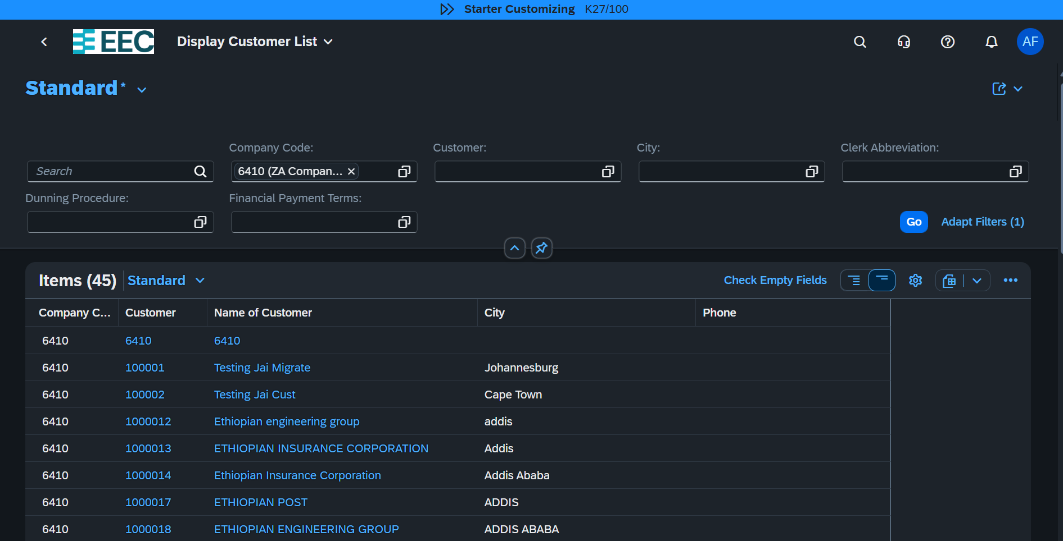

* Manage Customer Master Data

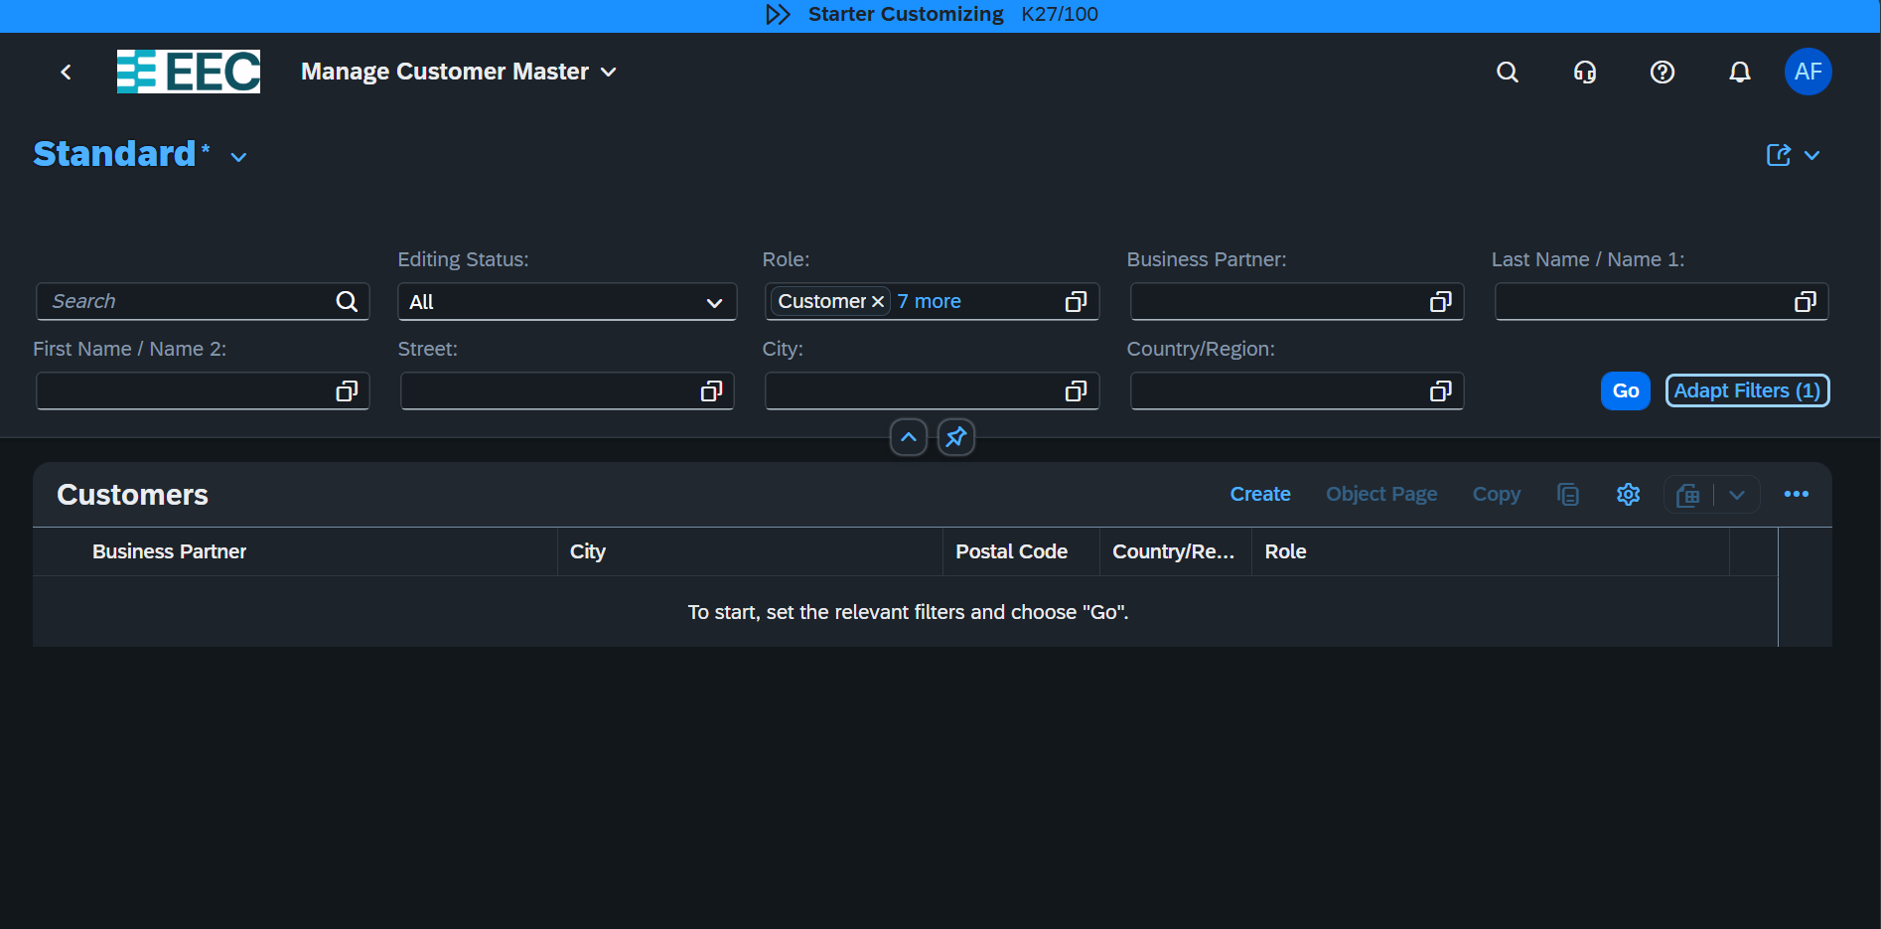

* Create Customer : select the grouping BP02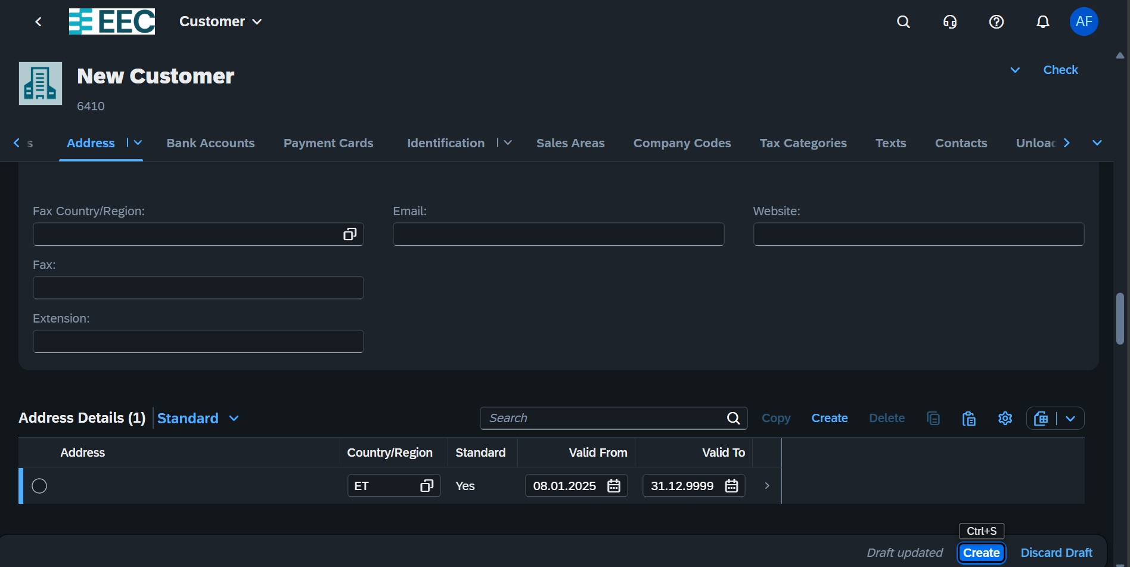

Creating Outgoing Invoice

Type “create ***Outgoing invoice***”

Uploading

**Day 03**

Material Management

Creating Service Requisition

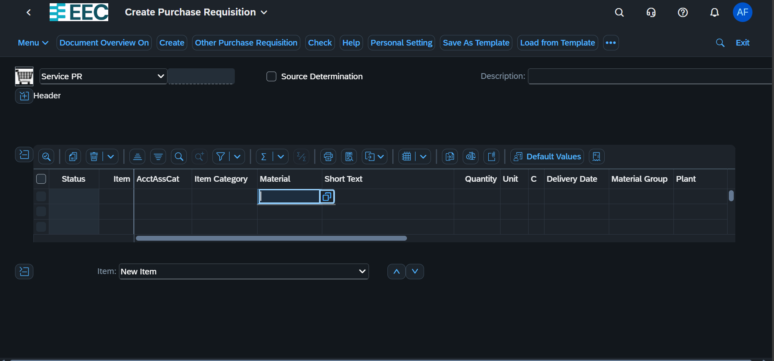

Stock Transfer it follows the same step with purchase requestion

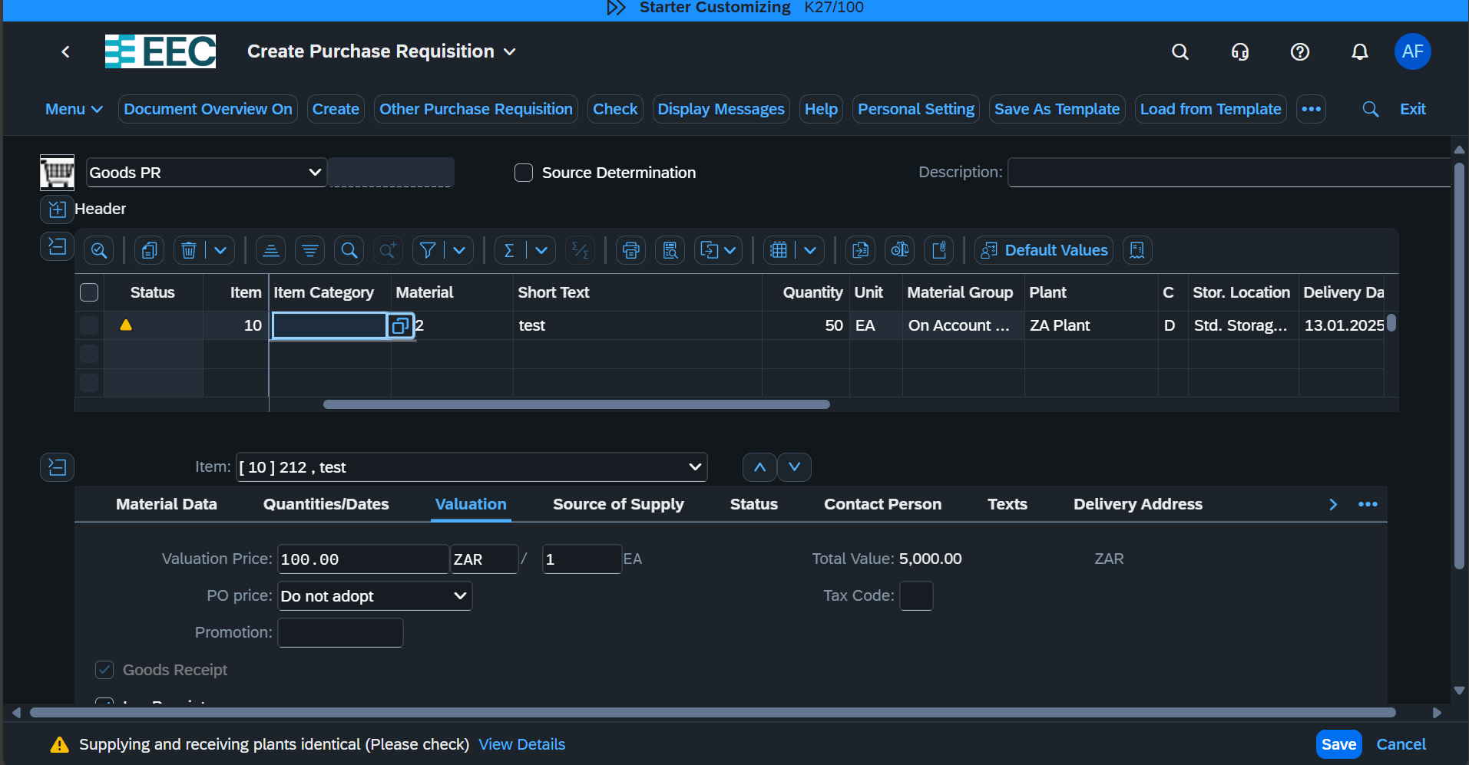

 4000000028

**Day 04 1/9/2025**

Create Supplier *Same Step With the previous*

Supplier Invoice

Invoice Creation without Purchase order

Supplier Down payment

Type Manage Supplier Down Payment

Then press Create button and

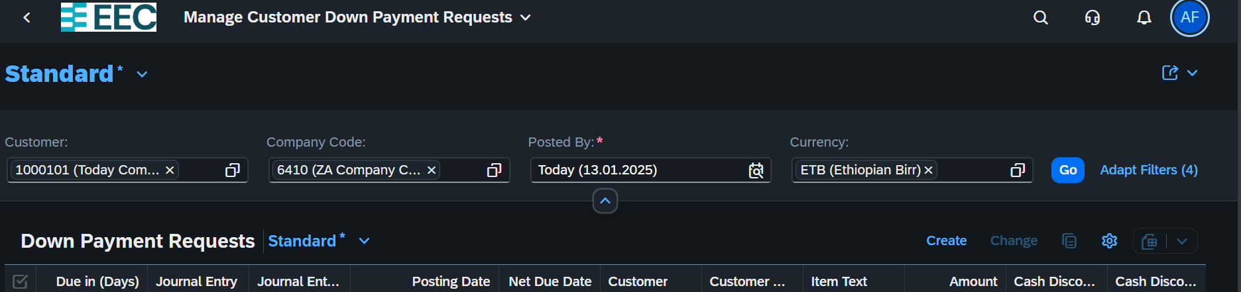

Then fill all Necessary information f and simulate to Check

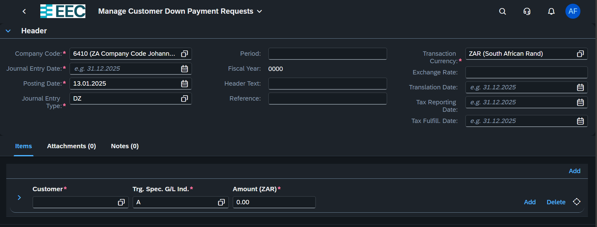

After we have simulated, we need to Check the document since we cannot edit rather, we can reverse it

Then Create invoice for this Downpayment

App Name: Create Outgoing Invoice

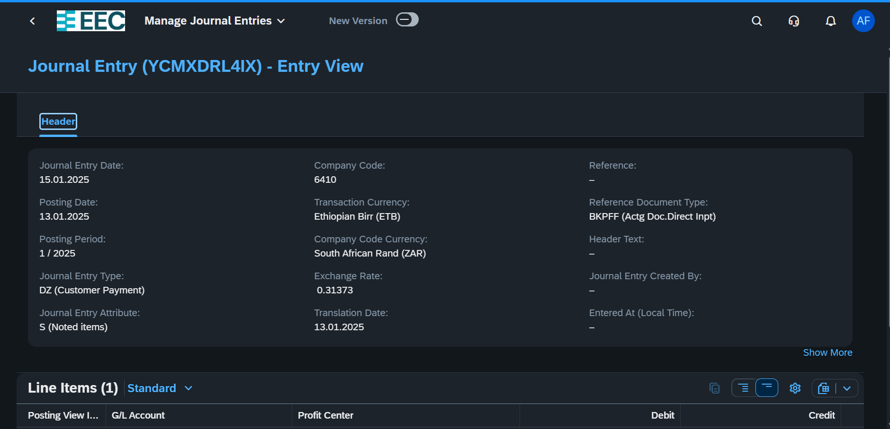

Credit memo:

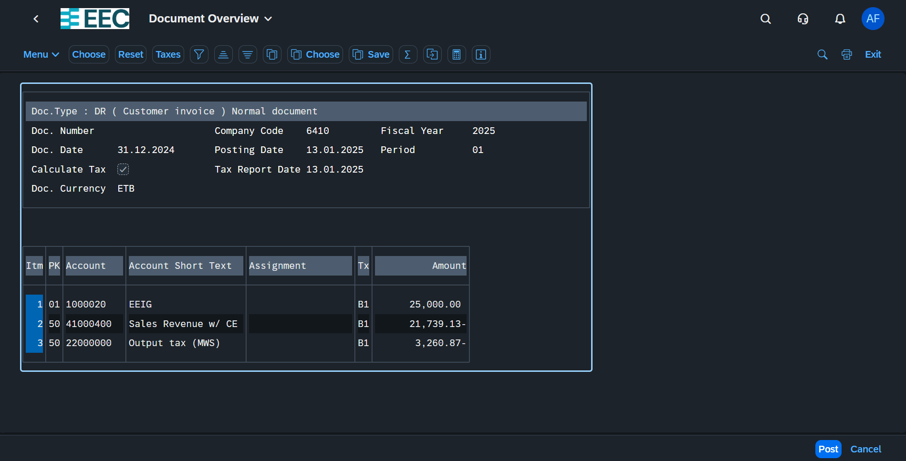

Then we need to manage Customer Line Item

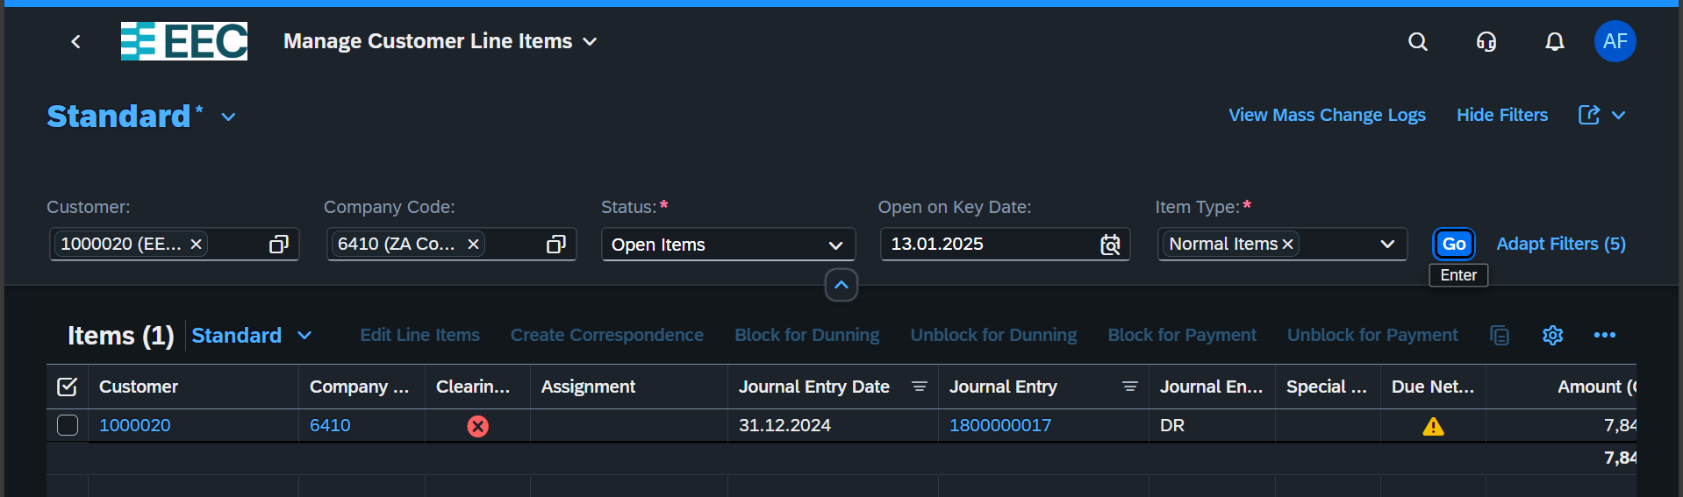

After creating invoice, we need to post the incoming payment

Type post incoming payment

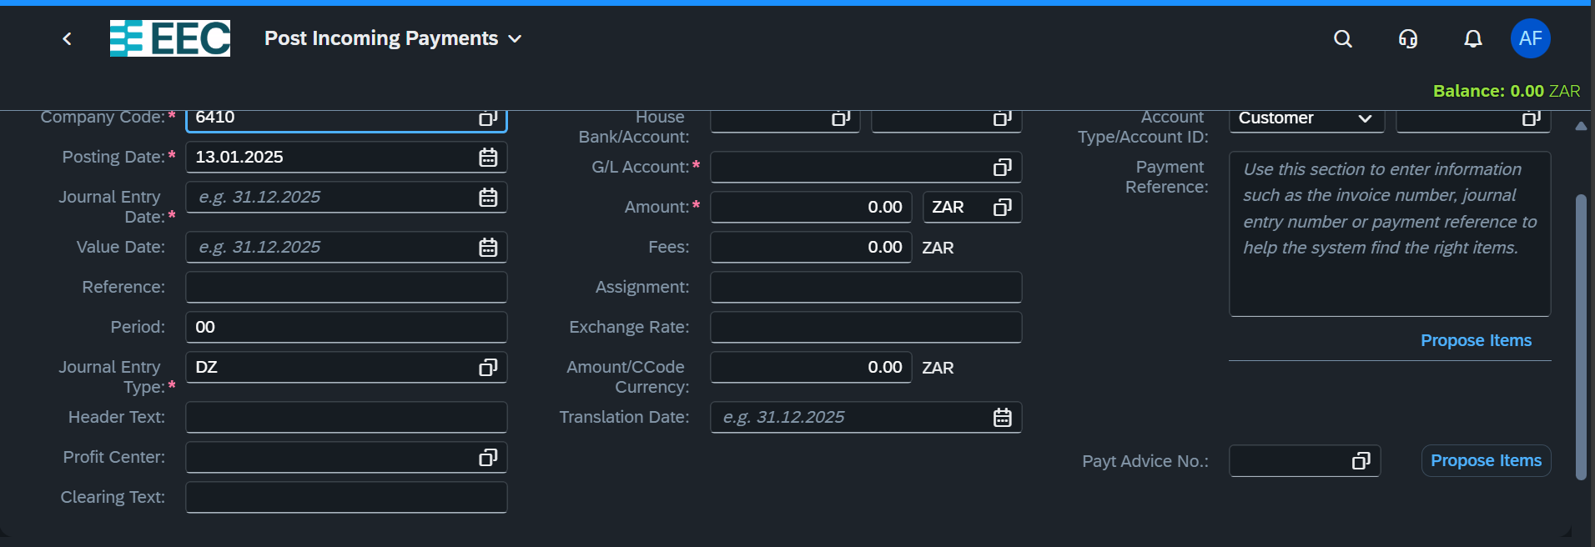

**Day 5: 1/10/2025**

* Manage Fixed Asset
* Change fixed Asset
* Display Fixed Asset

App Name: Manage Fixed Asset

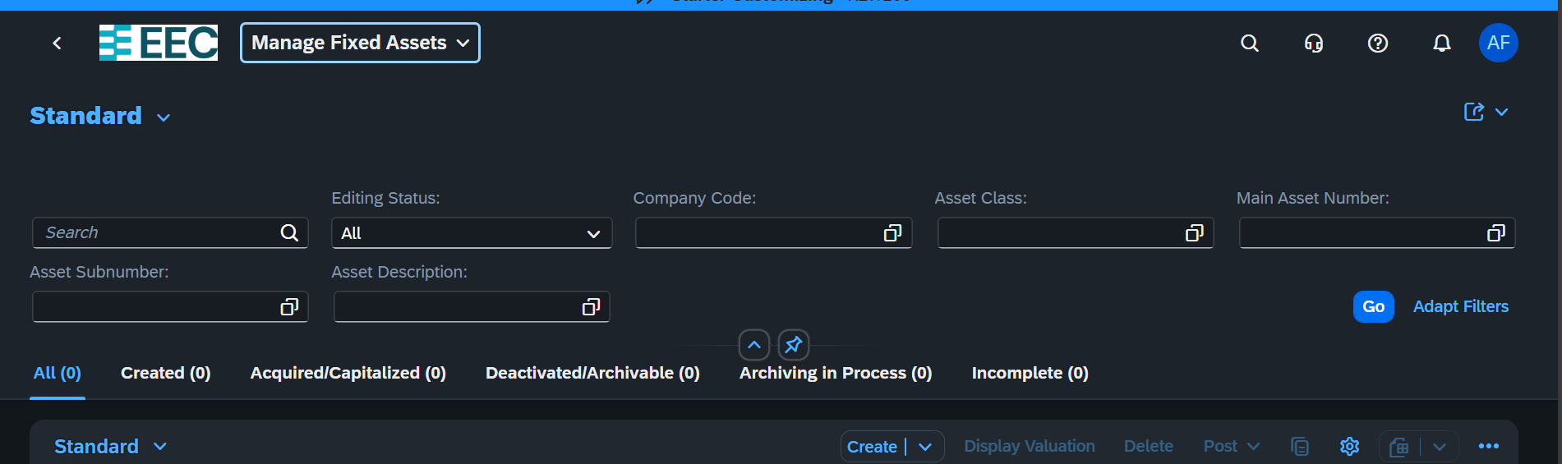

Click the Create Button to create New Asset

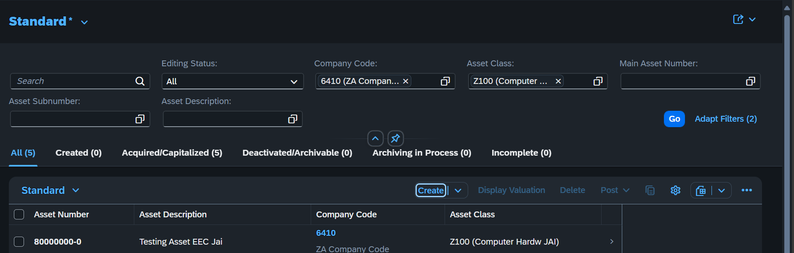

The press e “OK” to fill necessary information about the asset

All information including GL, Deprecation, profit Center, Cost Center

What about Bulk Products?

How to Check the owner for created Asset?

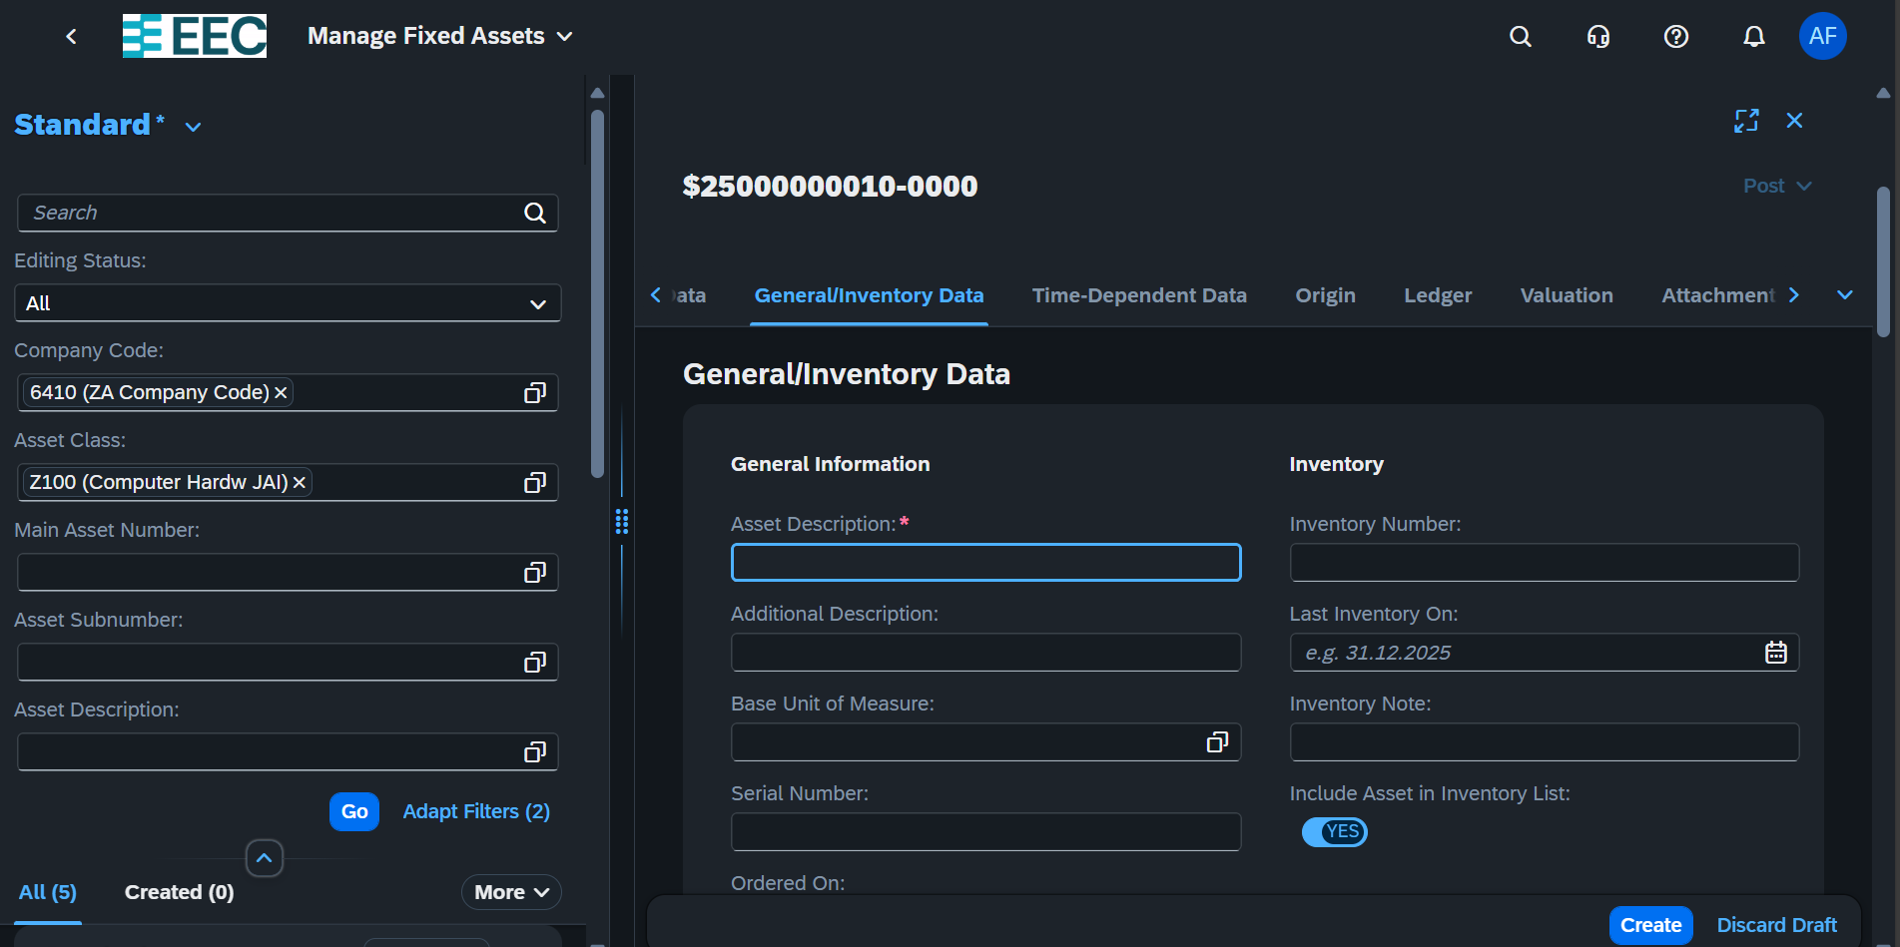

We can also edit Change Lock and Delete

After we Have Created Asset we can create Supplier invoice and use that asset code

**Deprecation Posting**